ArduinoTrack Assembly
Version 1.0 for PCB Version 1.11

Switch S1  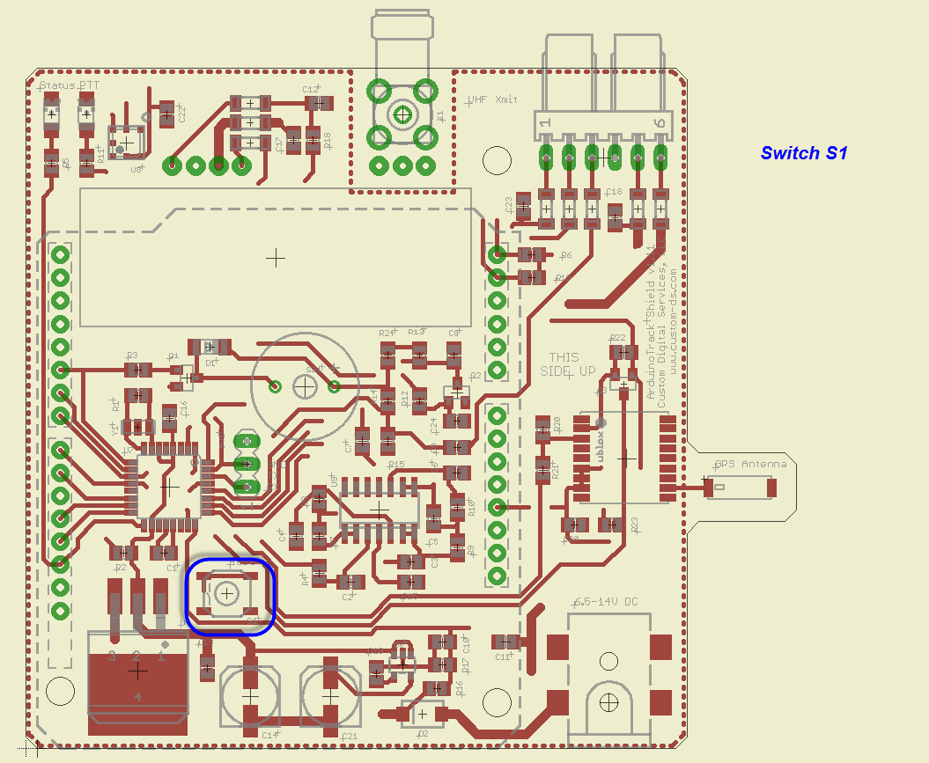 | Resonator Y1  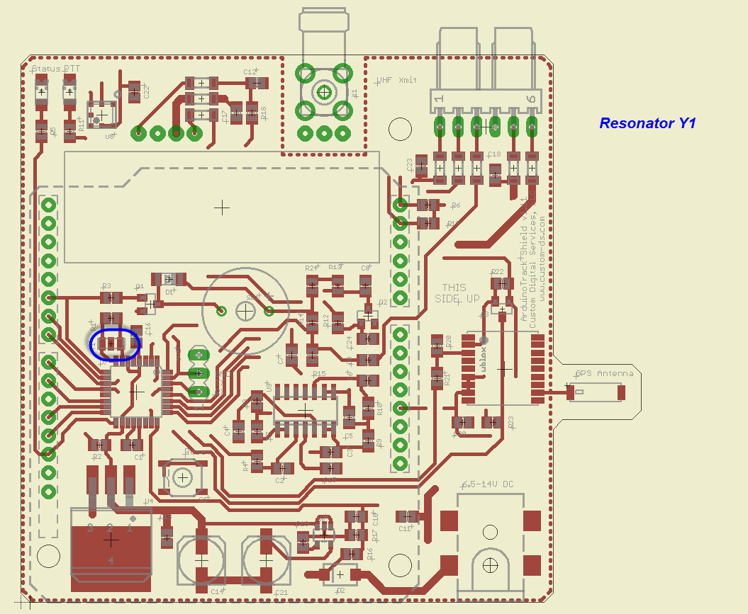
Green LED LED1  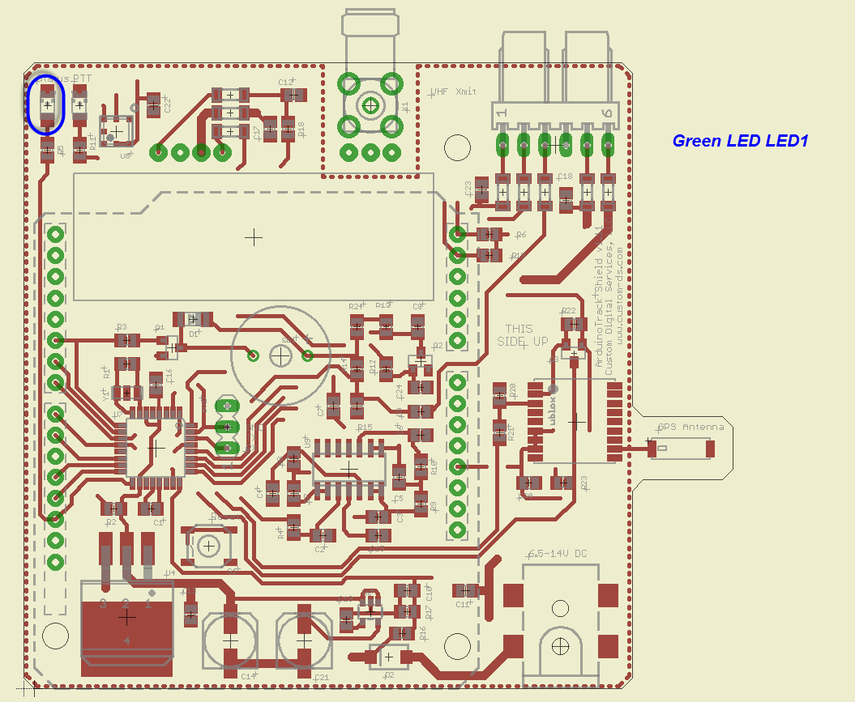 | Red LED LED2  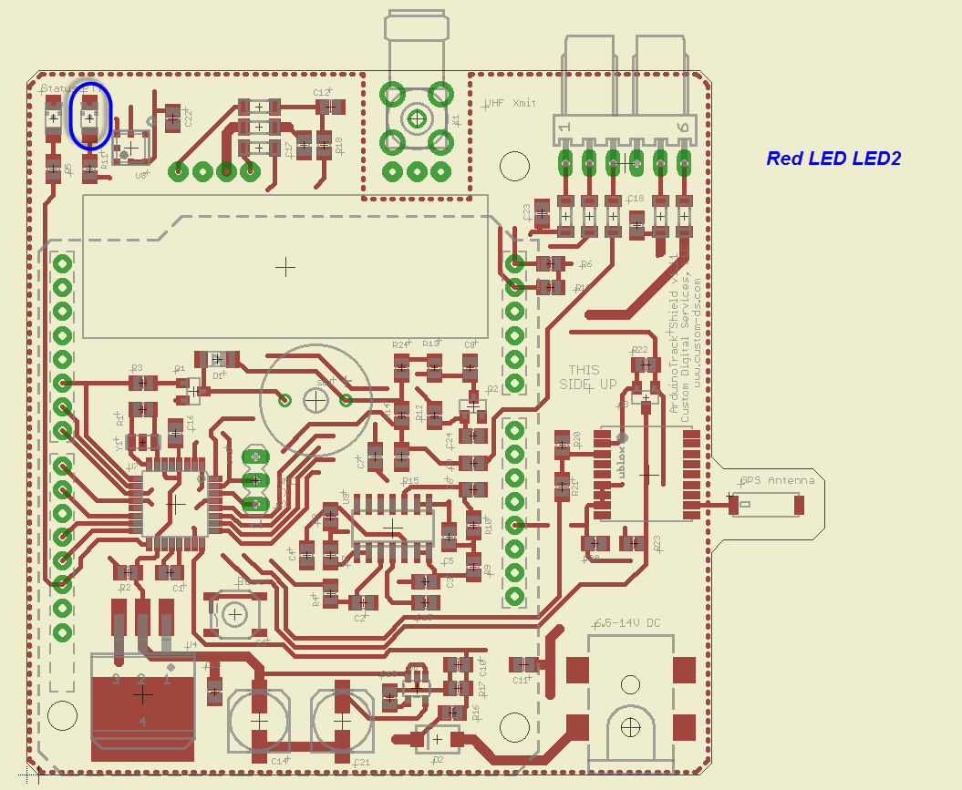
Transistors Q1, Q2  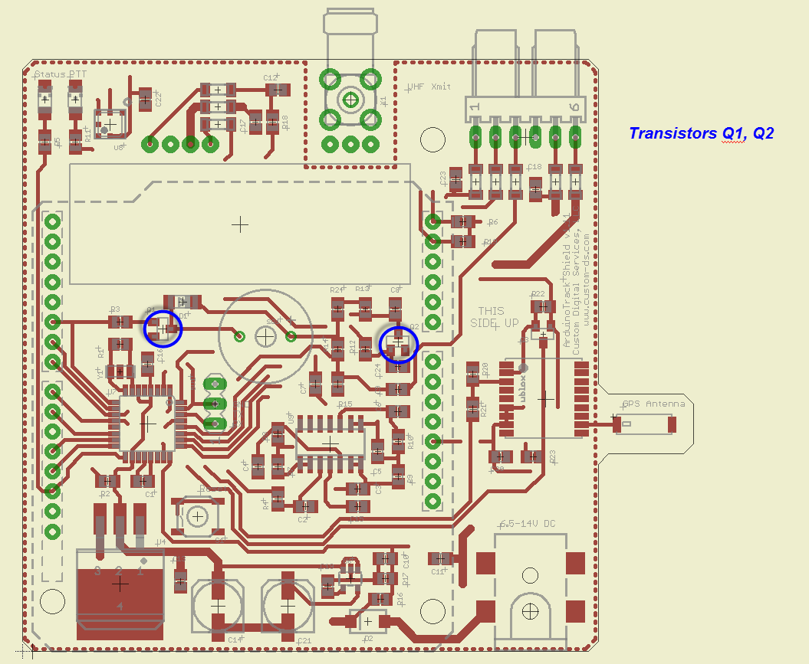 | FET Transistor Q3  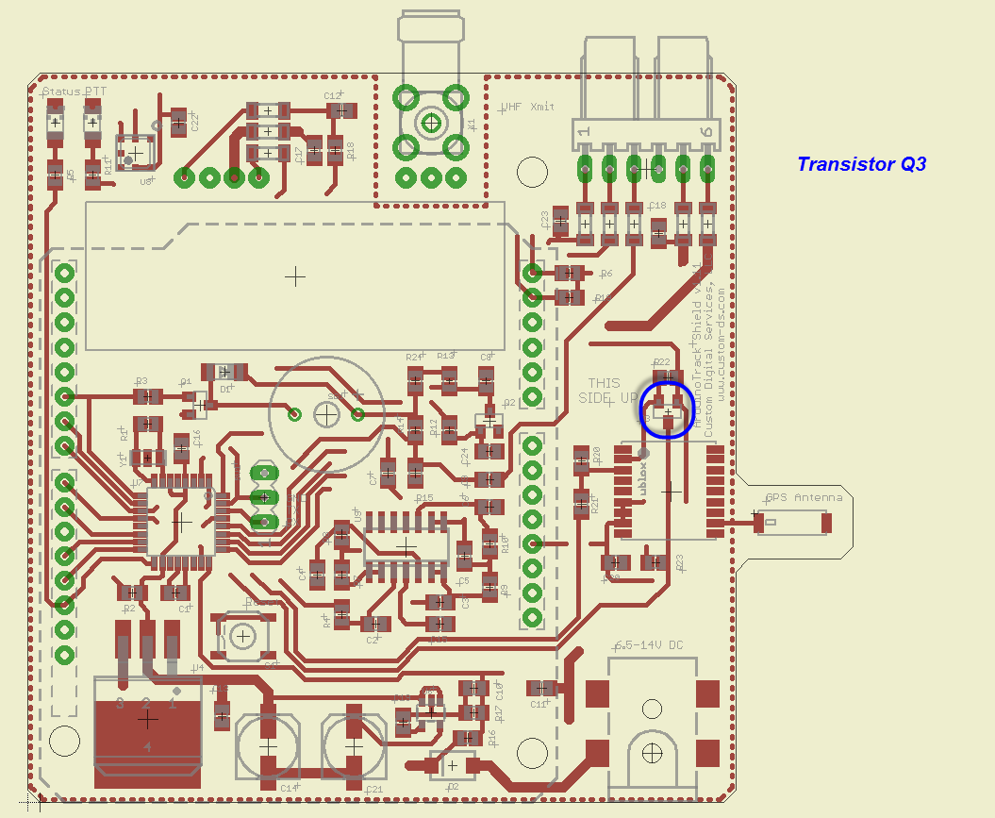
3.3V Regulator U6  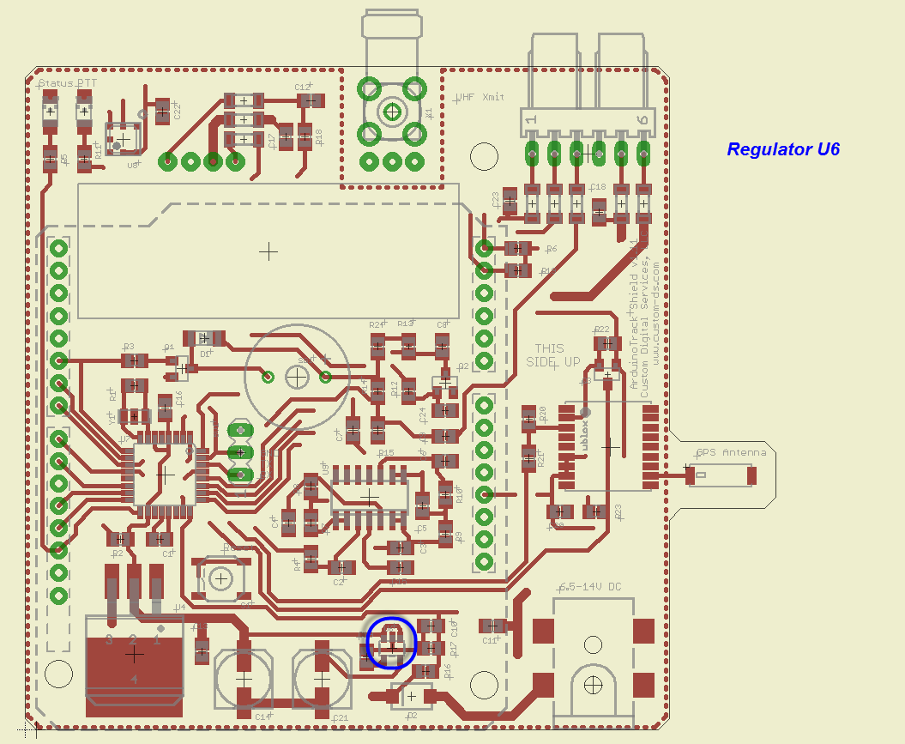 | GPS Antenna ANT1  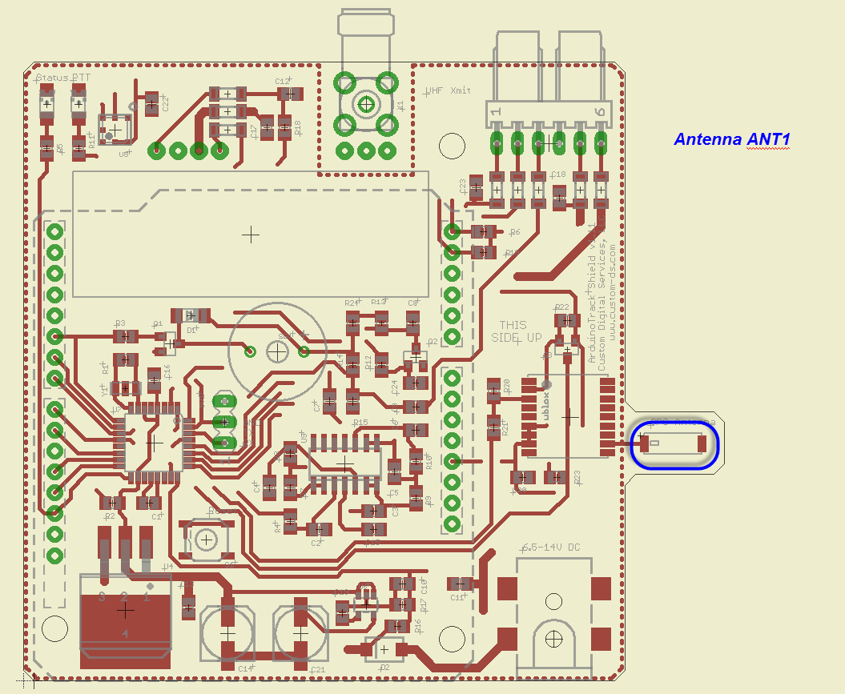
BMP180 Temp/Baro Sensor U8  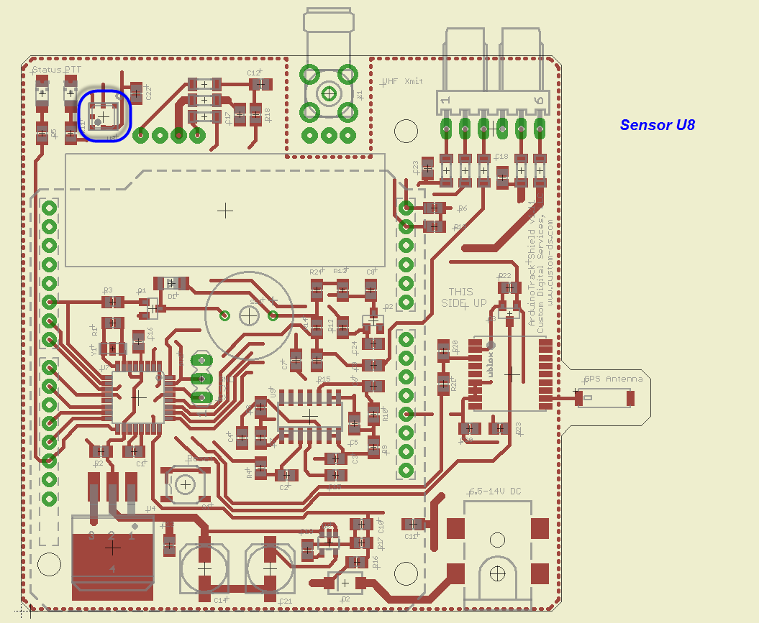 | Schottky Protection Diode D2  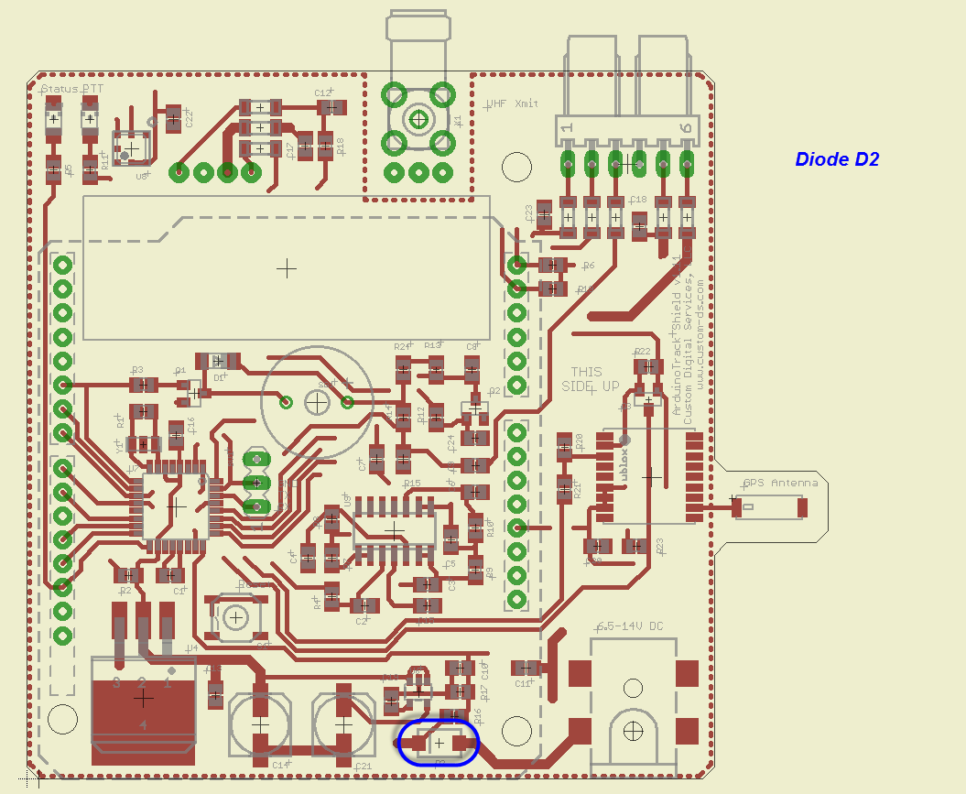
Ferrite Beads L1-L8  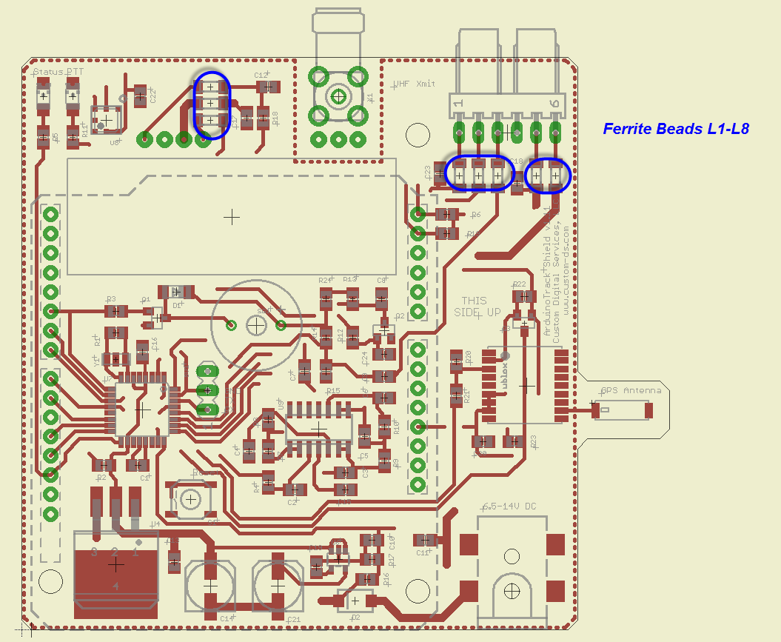 | 100Ω Resistor R18  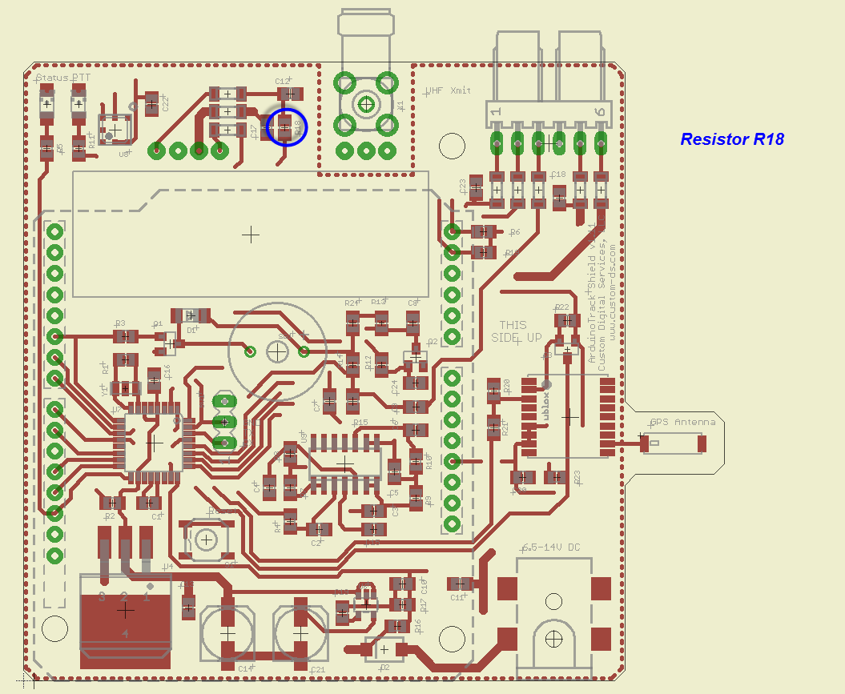
390Ω Resistor R9  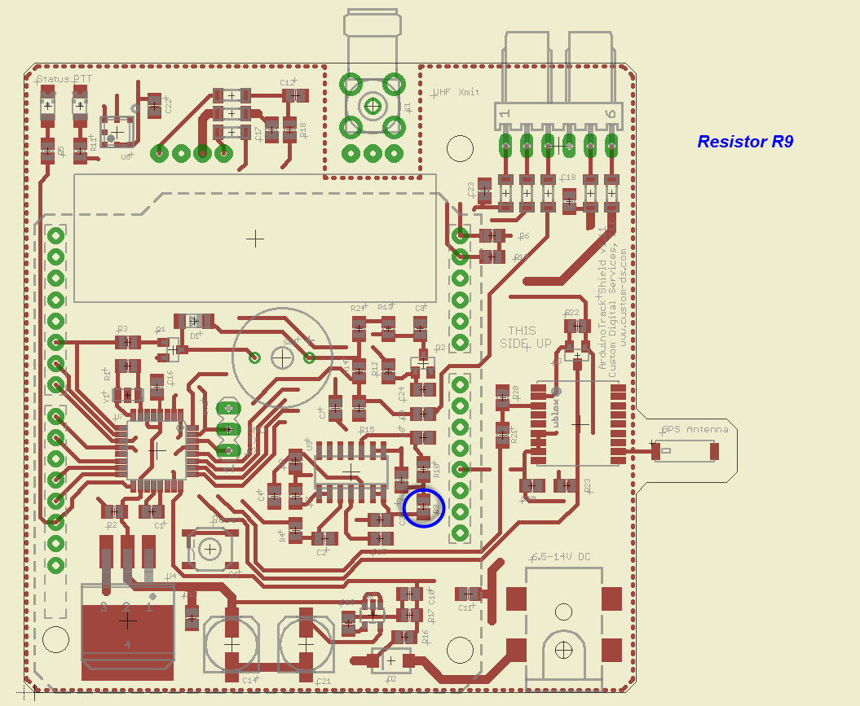 | 1M Resistor R1  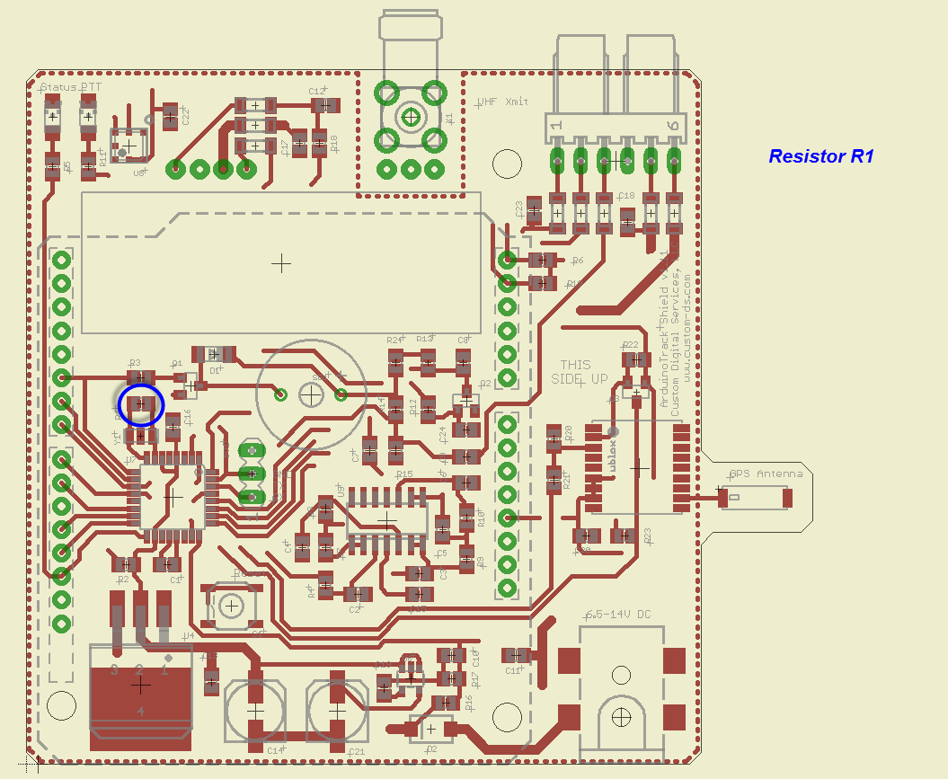
2.2k Resistors R7, R13  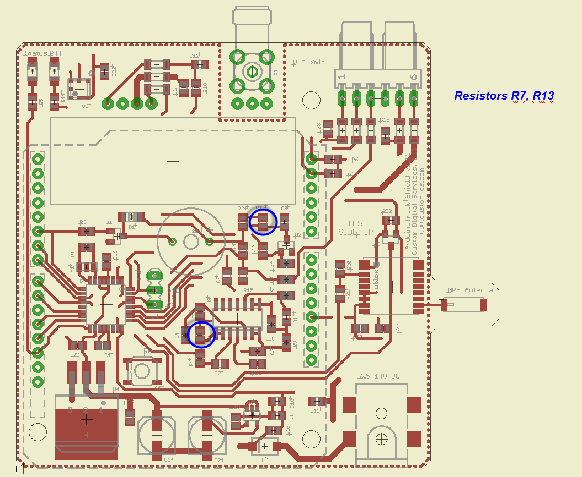 | 47k Resistors R17, R21  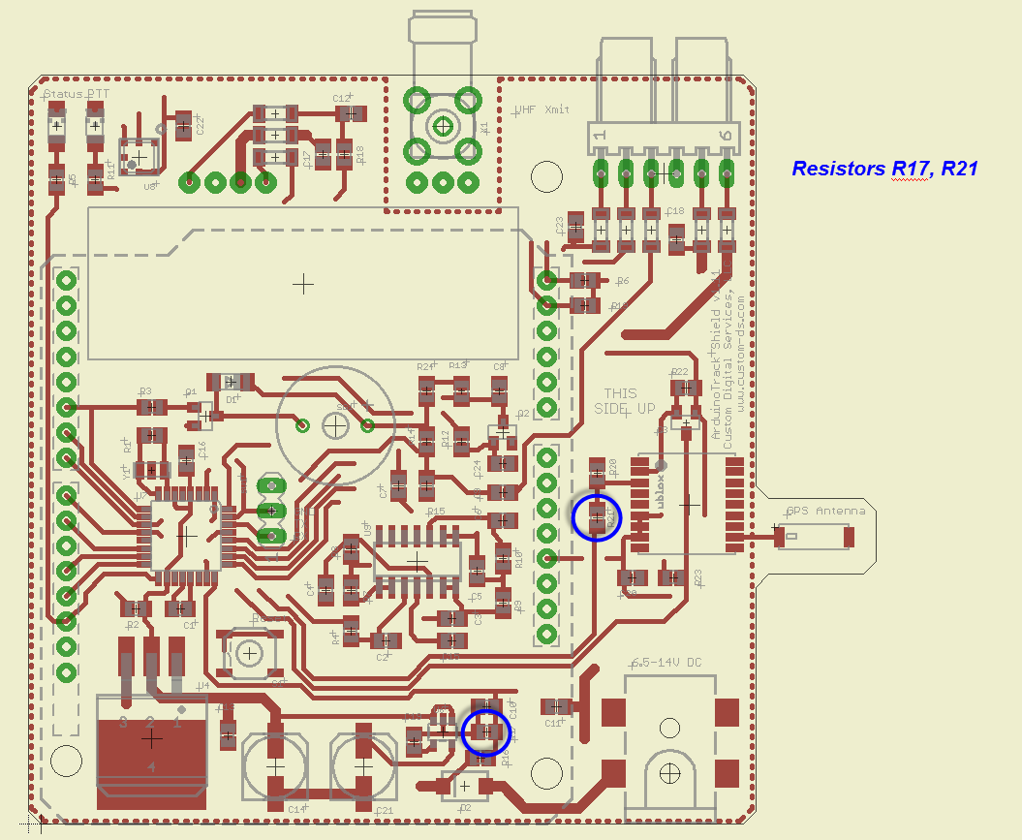
100k Resistors R16, R20  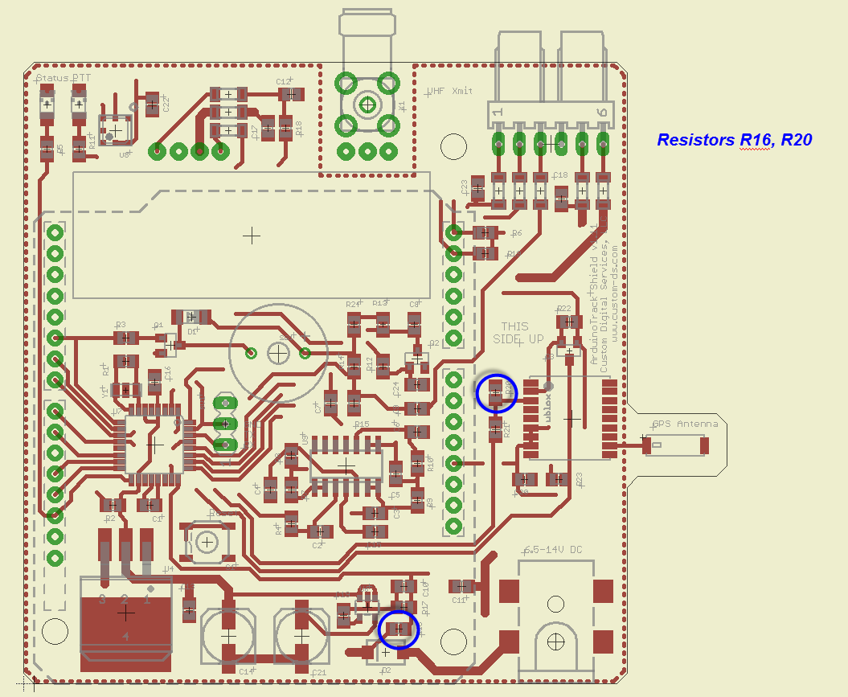 | 4.7k Resistors R6, R8, R19  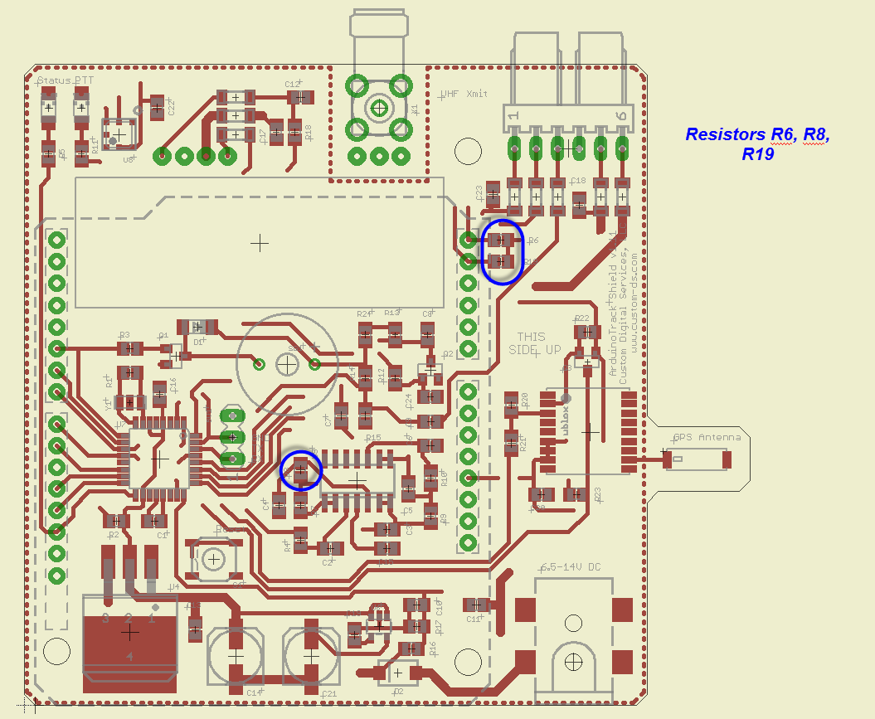
1k Resistors R3, R5, R10-R12  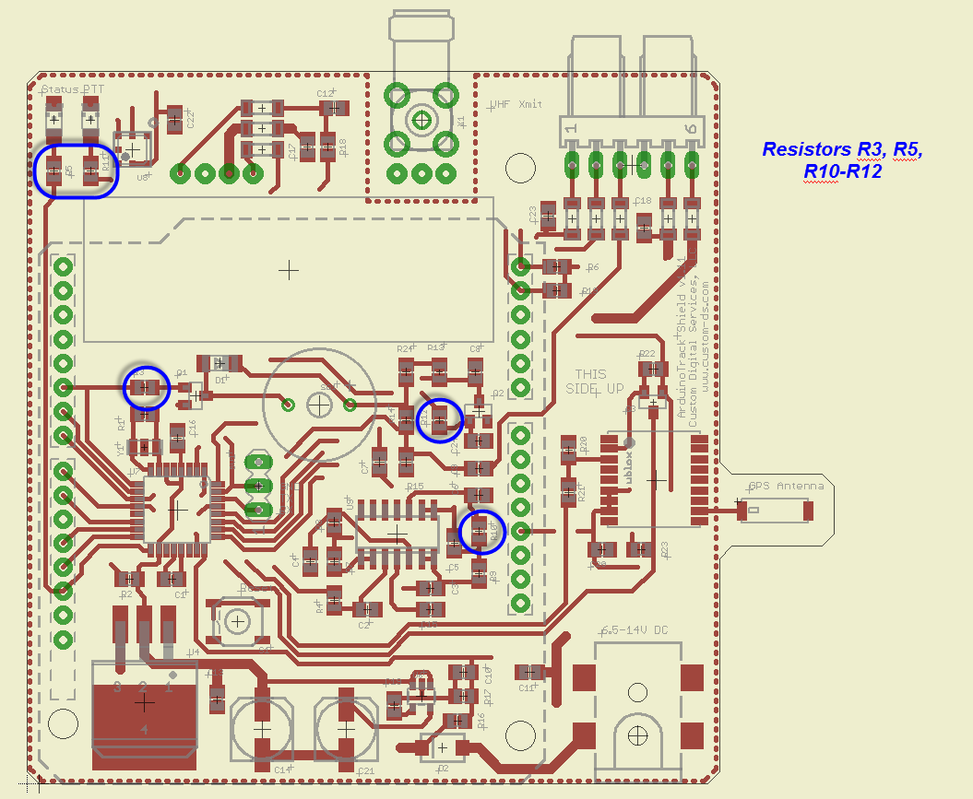 | 10k Resistors R2, R4, R14, R15, R22-R24  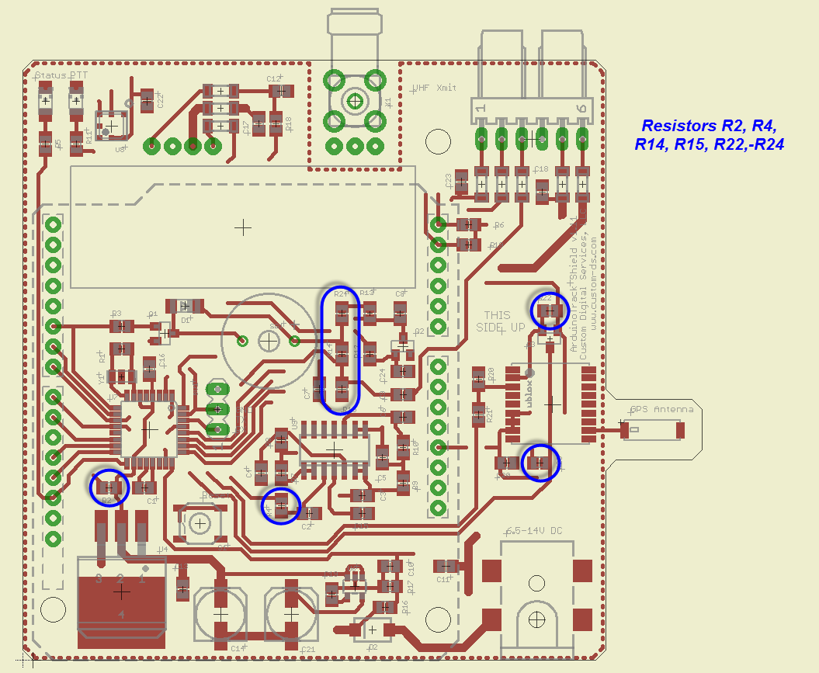
47nF Capacitors C3, C5  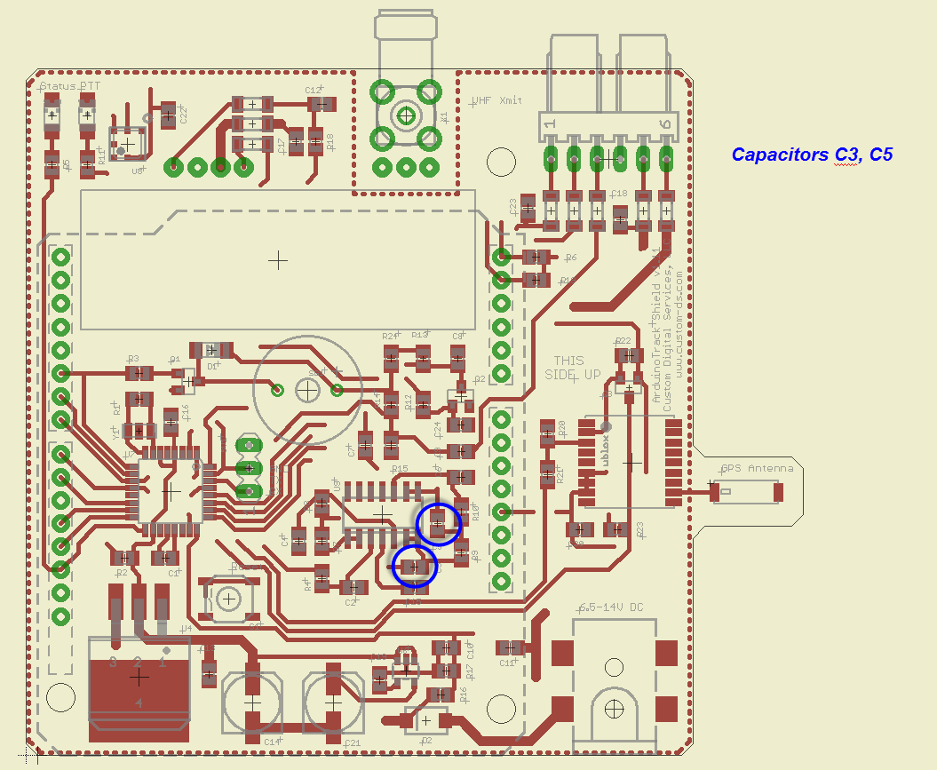 | 10nF Capacitors C2, C4, C6, C8, C12, C23  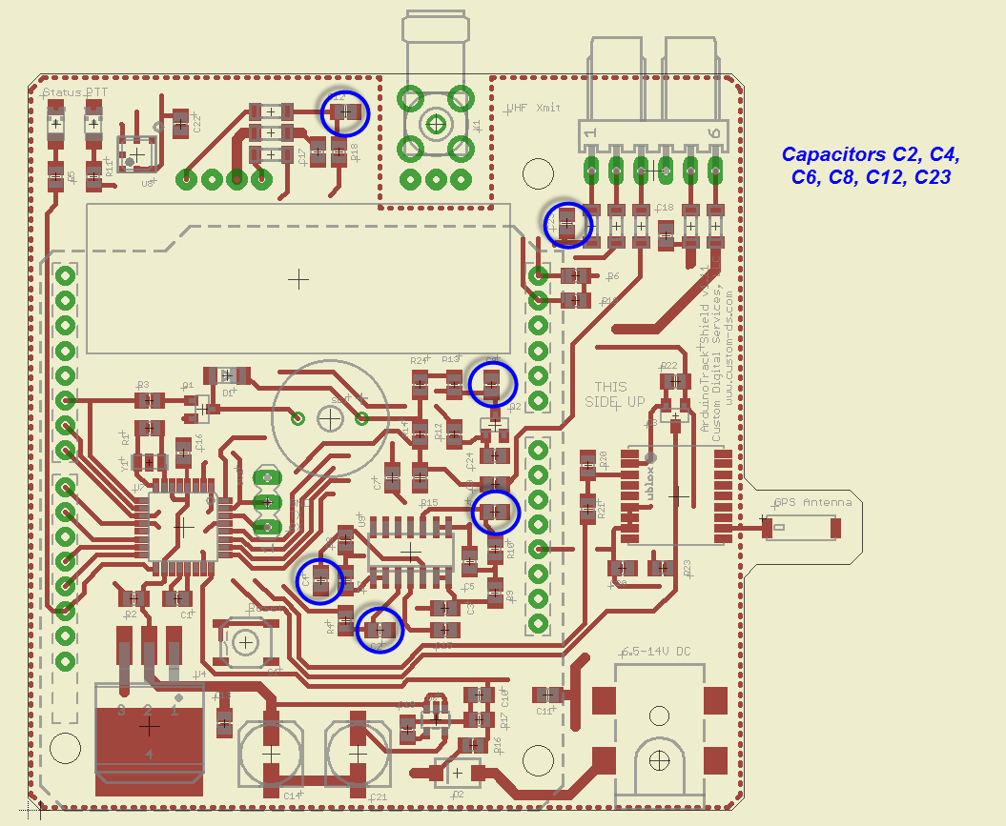
.1μF Capacitors C1, C7, C9-C11, C15-C20, C22, C24  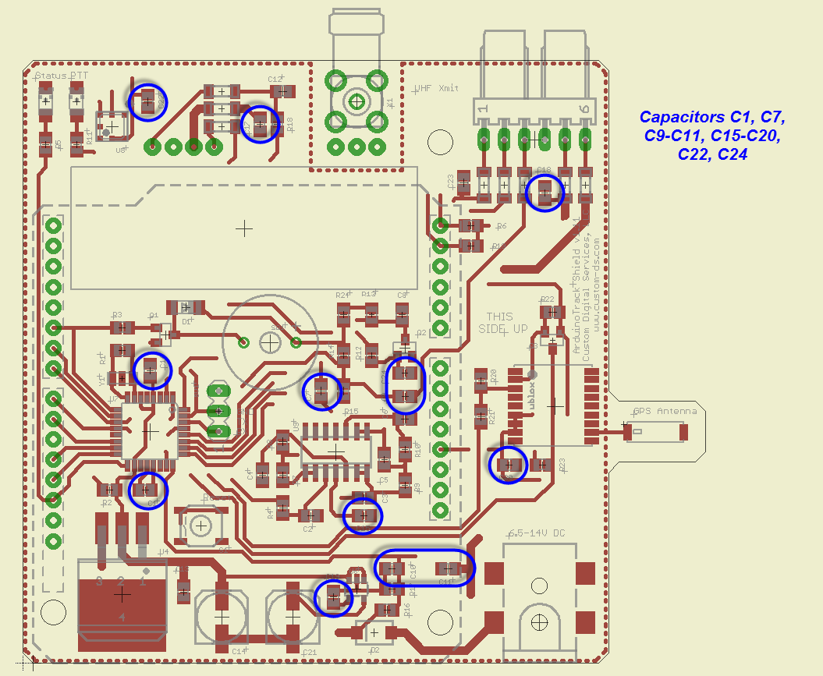 | ATMega328p μController U7  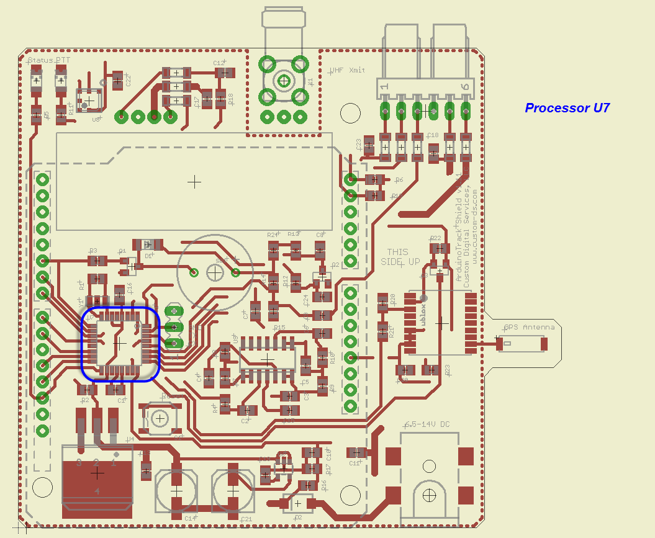
MCP6L04T Op-Amp U9  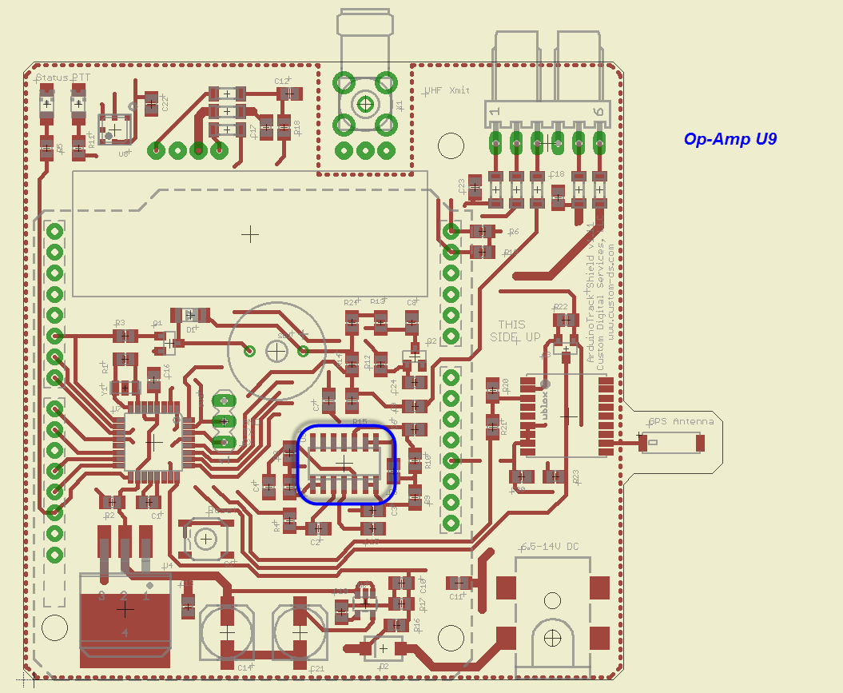 | uBlox MAX-M8Q GPS Module U3  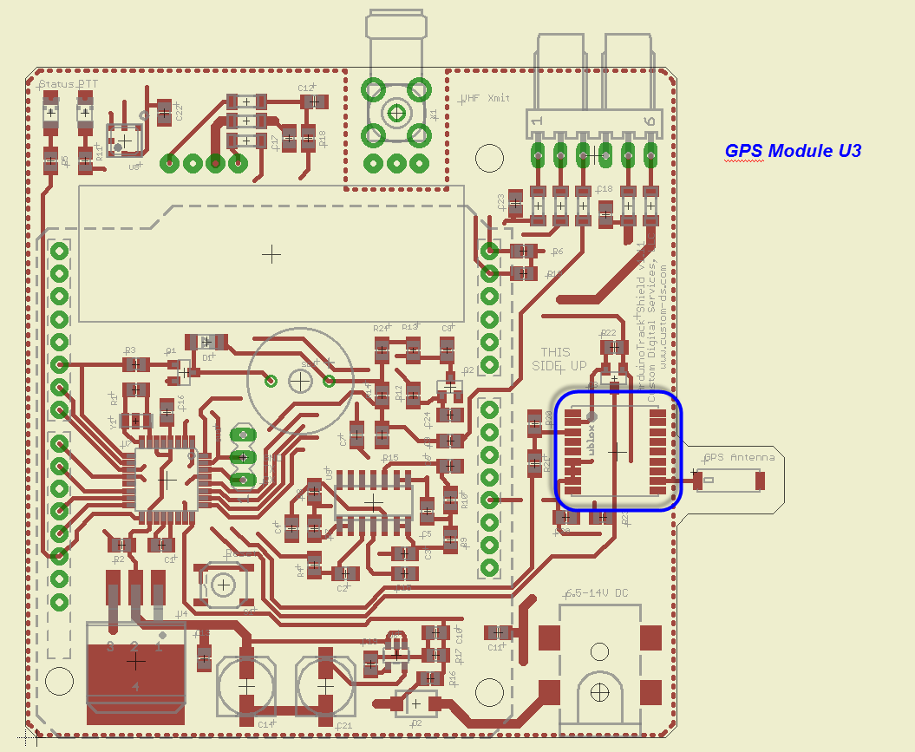
Diode D1  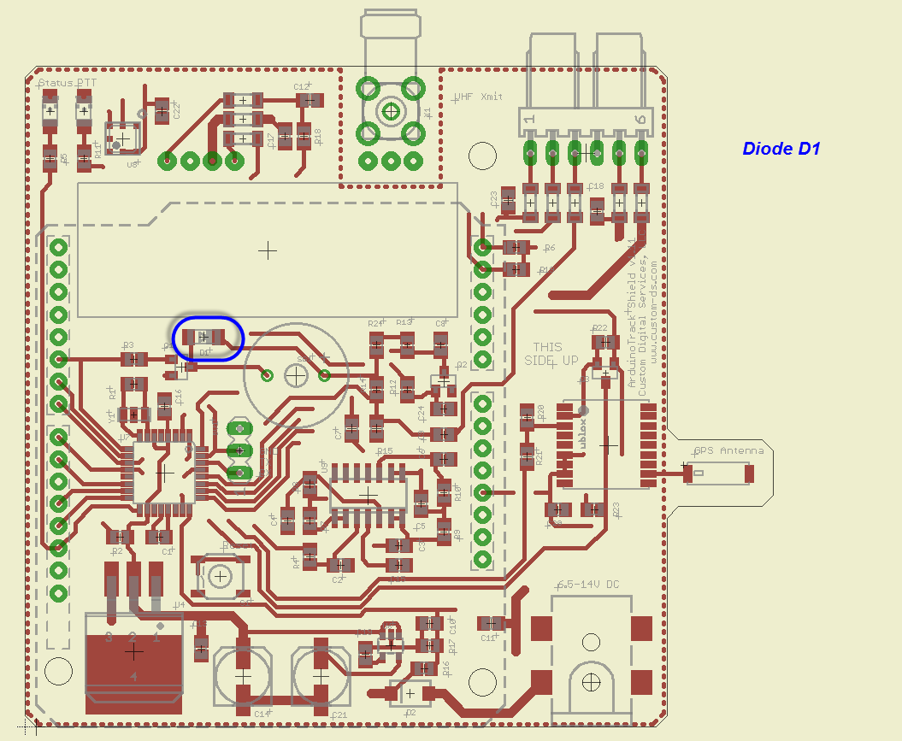 | 5V Regulator U4  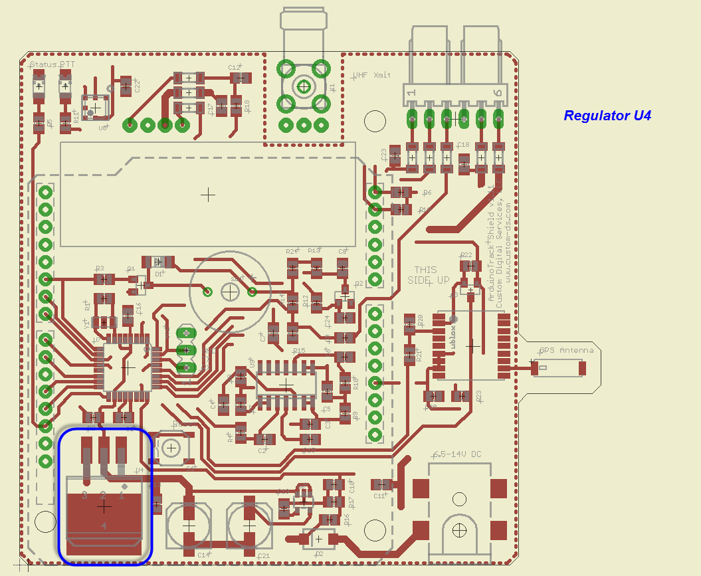
47μF Electrolytic Capacitors C14, C21  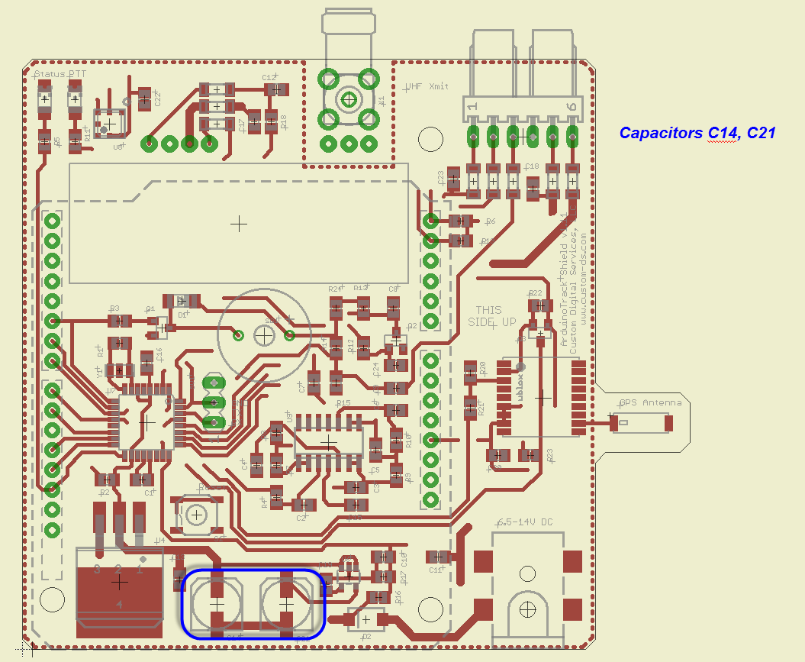 | Power Jack J1  